This is the Access exam covering chapters 1-3 named ACC1-3EXAM. It is an open book objective based test consisting of 42 multiple choice questions from the readings in the textbook. This exam is due by 11:59PM on Sunday, Jul 19, 2015.

Access Chapter 1 — Databases and Database Objects: An Introduction
- ____ words are words that have a special meaning to Access and cannot be used for the names of fields.
- Reserved
- Restricted
- Significant
- Tagged
- A field whose data type is ____ can store an OLE object, which is an object linked to or embedded in the table.
  - Illustration
  - Image
  - Bitmap
  - OLE object
- A field whose data type is ____ can store text that can be used as a hyperlink address.
  - URL
  - Web
  - Placeholder
  - Hyperlink
- When you assign a(n) ____ to a field, Access will display the value you assign, rather than the field name, in datasheets and in forms.
  - alternate
  - caption
  - abbreviation
  - tag
- In a(n) ____ database such as those maintained by Access, a database consists of a collection of tables, each of which contains information on a specific subject.
  - Tabular
  - record
  - attribute
  - relational
- In the accompanying figure below, the key symbol that appears in the row selector for the Book Rep Number field indicates that Book Rep Number is the ____ for the table.
  - principal key
  - foreign key
  - main key
  - primary key
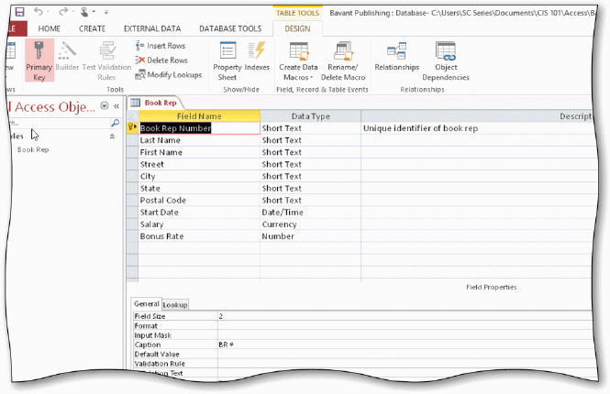
- To import data to a table, tap or click the ____ tab on the ribbon.
  - DATABASE TOOLS
  - FILE
  - EXTERNAL DATA
  - IMPORT
- To create a query using the Query Wizard, tap or click ____ on the ribbon and then click the Query Wizard button.
  - CREATE
  - INSERT
  - NEW OBJECT
  - REPORT
- To compact and repair a database, tap or click the ___ button in the Info gallery in the Backstage view.
  - Restore
  - Fix
  - Compaction
  - Compact & Repair

- In Access, table and field names can be up to ____ characters in length.
  - 256
  - 128
  - 64
  - 32
- A field with the ____ data type can store a unique sequential number that Access assigns to a record. Access will increment the number by 1 as each new record is added.
  - Sequential
  - ValueIncrement
  - Incremental
  - AutoNumber
- A field with the ____ data type can contain an attached file, such as an image, document, chart, or spreadsheet.
  - Attachment
  - File
  - Document
  - Extend

Access Chapter 2 — Querying a Database
- To find all customers whose names begin with S, enter ____ in the Criteria row of the Customer Name field.
  - S?
  - S*
  - S#
  - S&
- To find all customers whose current due amount is greater than $1,000.00, enter ____ in the Criteria row of the Current Due column.
- $1000
- 1000
- 1,000
- $1,000
- To sort records in a query, specify the sort order in the ____ row of the design grid below the field that is the sort key.
  - Show
  - List
  - Sort
  - Order
- To include calculated fields in queries, enter a name for the calculated field, a(n) ____, and then the expression in one of the columns in the Field row.
  - colon (:)
  - semi-colon (;)
  - equal sign (=)
  - exclamation point (!)

- You can include ____ in calculations to indicate which calculation should be done first.
  - curly braces { }
  - brackets [ ]
  - parentheses ( )
  - slashes //
- To change the caption for a field in a query, click the field in the design grid, click the ____ button on the Design tab, click the Caption box, and enter the new caption.
  - Caption
  - Property Sheet
  - Field Name
  - Format
- To include the Total row in the design grid, click the ____ button on the DESIGN tab.
  - Aggregate
  - Statistics
  - Calculations
  - Totals
- To find the largest amount paid amount for a client, select ____ as the entry in the Total row for the Amount Paid column.
  - Large
  - Maximum
  - LGE
  - MAX
- To calculate statistics for only those records that satisfy certain criteria, select ____ as the entry in the Total row for the field, and then enter the criterion in the Criteria row.
  - Having
  - Where
  - Restrict
  - Find
- To indicate grouping in Access, select ____ as the entry in the Total row for the field to be used for grouping.
  - Like
  - Where
  - Same
  - Group By
- To change the design of a query that is not currently open, press and hold or right-click the query and then tap or click ____ on the shortcut menu.
  - Datasheet View
  - Layout View
  - Change View
  - Design View

Access Chapter 3 — Maintaining a Database
- To clear a filter, tap or click the ____ button on the HOME tab and then tap or click Clear All Filters.
  - Filter
  - Remove
  - Advanced
  - Select
- To use a common filter to find only those customers whose city begins with G, tap or click the arrow to the right of the field name and point to the ____ command to display the custom text filters.
  - Text Filters
  - Character Filters
  - Common Filters
  - Common Character Filters
- When you use Filter By Form to restrict records that appear, you create the filter and then tap or click the ____ button to apply the filter.
  - Apply Filter
  - Filter
  - Toggle Filter
  - Select
- A ___ field allows the user to select from a list of values.
  - list
  - lookup
  - combo
  - value
- To change the list of choices in a single or multivalued lookup field, open the table in Design view, select the field to be modified, and tap or click the ____ tab in the Field Properties pane.
  - Modify
  - Change
  - Edit
  - Lookup
- A(n) ____ field is a field that can be computed from other fields.
  - aggregate
  - combined
  - total
  - calculated
- To update records using an update query, enter the field to be updated in the design grid, enter any necessary criterion, and then tap or click the ____ button to update the records.
  - Run
  - View
  - Execute
  - Update

- A(n) ____ query adds a group of records from one table to the end of another table.
  - insert
  - append
  - add
  - supplement
- To specify that a field is to be required, change the value for the _____ property from No to Yes.
  - Required
  - No Blanks
  - Necessary
  - Completed
- To specify that entries in the Returns field must be between $0.00 and $30,000.00, enter ____ in the Validation Rule property box.
  - >=0, <=30,000
  - >=$0, <=$30,000
  - >=0 and <=30000
  - >=$0 and <=$30,000
- To indicate that the only allowable values for the Customer Type field are HS, COM, and UNI, enter ____ in the Validation Rule property box.
  - =HS or =COM or =UNI
  - HS, COM, UNI
  - must be HS, COM, or UNI
  - =HS, =COM, =UNI
- To save validation rules, default values, and formats, tap or click the Save button on the ____ to save the changes.
  - HOME tab
  - status bar
  - Quick Access Toolbar
  - DESIGN tab
- To remove a total row that appears in a datasheet, tap or click the ____ button on the HOME tab.
  - Toggle
  - Remove
  - Statistics
  - Totals
- To change a query so that each item in a multivalued field occurs on a different row, use the ____ property.
  - Field
  - Value
  - Unique
  - Distinct

- To find records in one table that have no matching records in another table, use the _____ Query Wizard.
  - No Matches
  - No Records
  - Find Unmatched
  - Find Records
- To order the records in the Customer table by city in alphabetical order, use the ____ button.
  - Order Ascending
  - Sort
  - Sort Ascending
  - Ascending
- To exit Access, click the ____ button on the right side of the Access title bar.
  - Quit
  - Exit
  - Close
  - Done
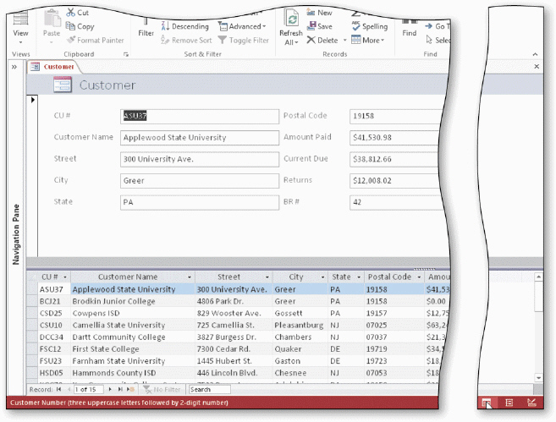

- To add a record using the form shown above in the accompanying figure, tap or click the ____ button on the Navigation bar.
  - Last record
  - New (blank) record
  - Insert record
  - Blank record
- To use Filter By Selection to find all customers located in Greer, tap or click the City field for any record where the city is Greer and then tap or click the ____ button on the HOME tab.
  - Selection
  - Filter By Selection
  - Find
  - Replace

